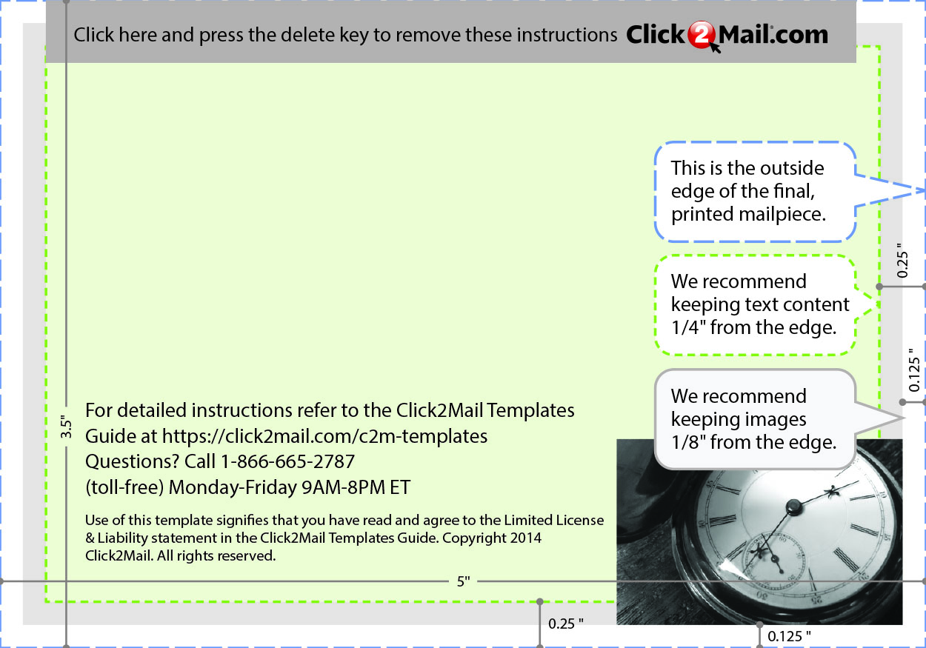
Use this template to produce the >
Postcard, Single-sided, finished size:
3.5 x 5 inches. Placeholder text...
Replace this placeholder text with text
of your own. Use Click2Mail.com to
print, finish, post, and deliver. 03/14

