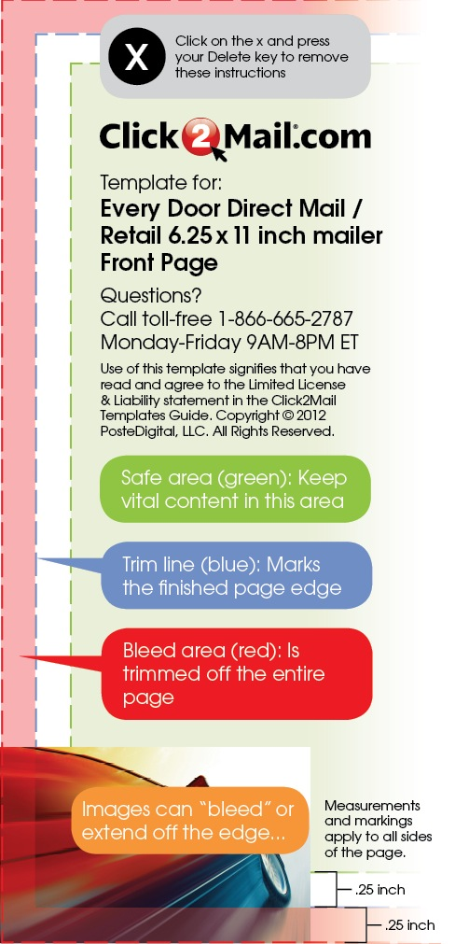
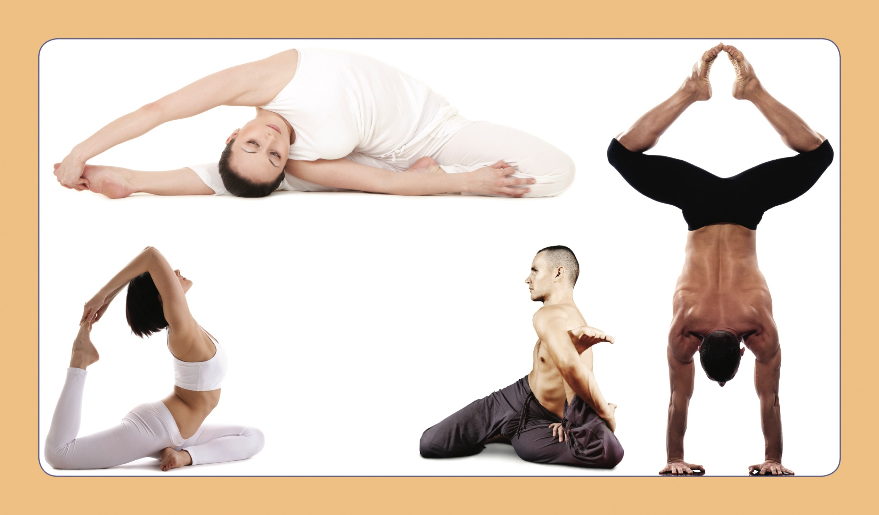

DON’T TRY THIS AT HOME

Come try it with us

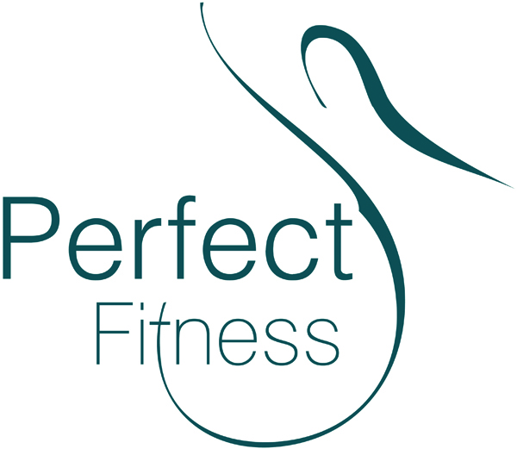

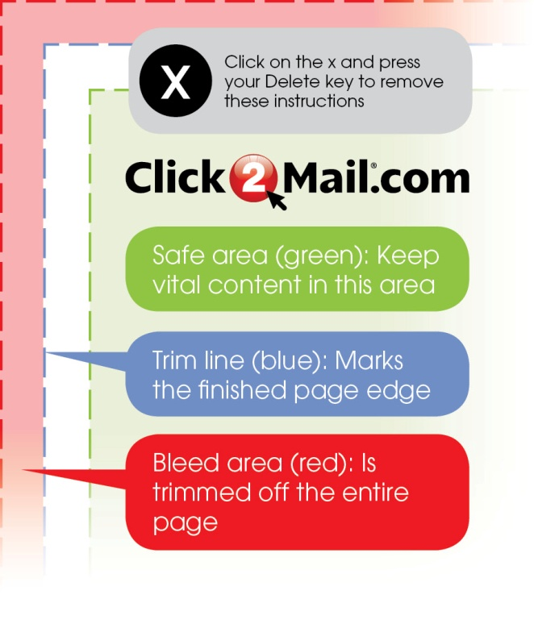
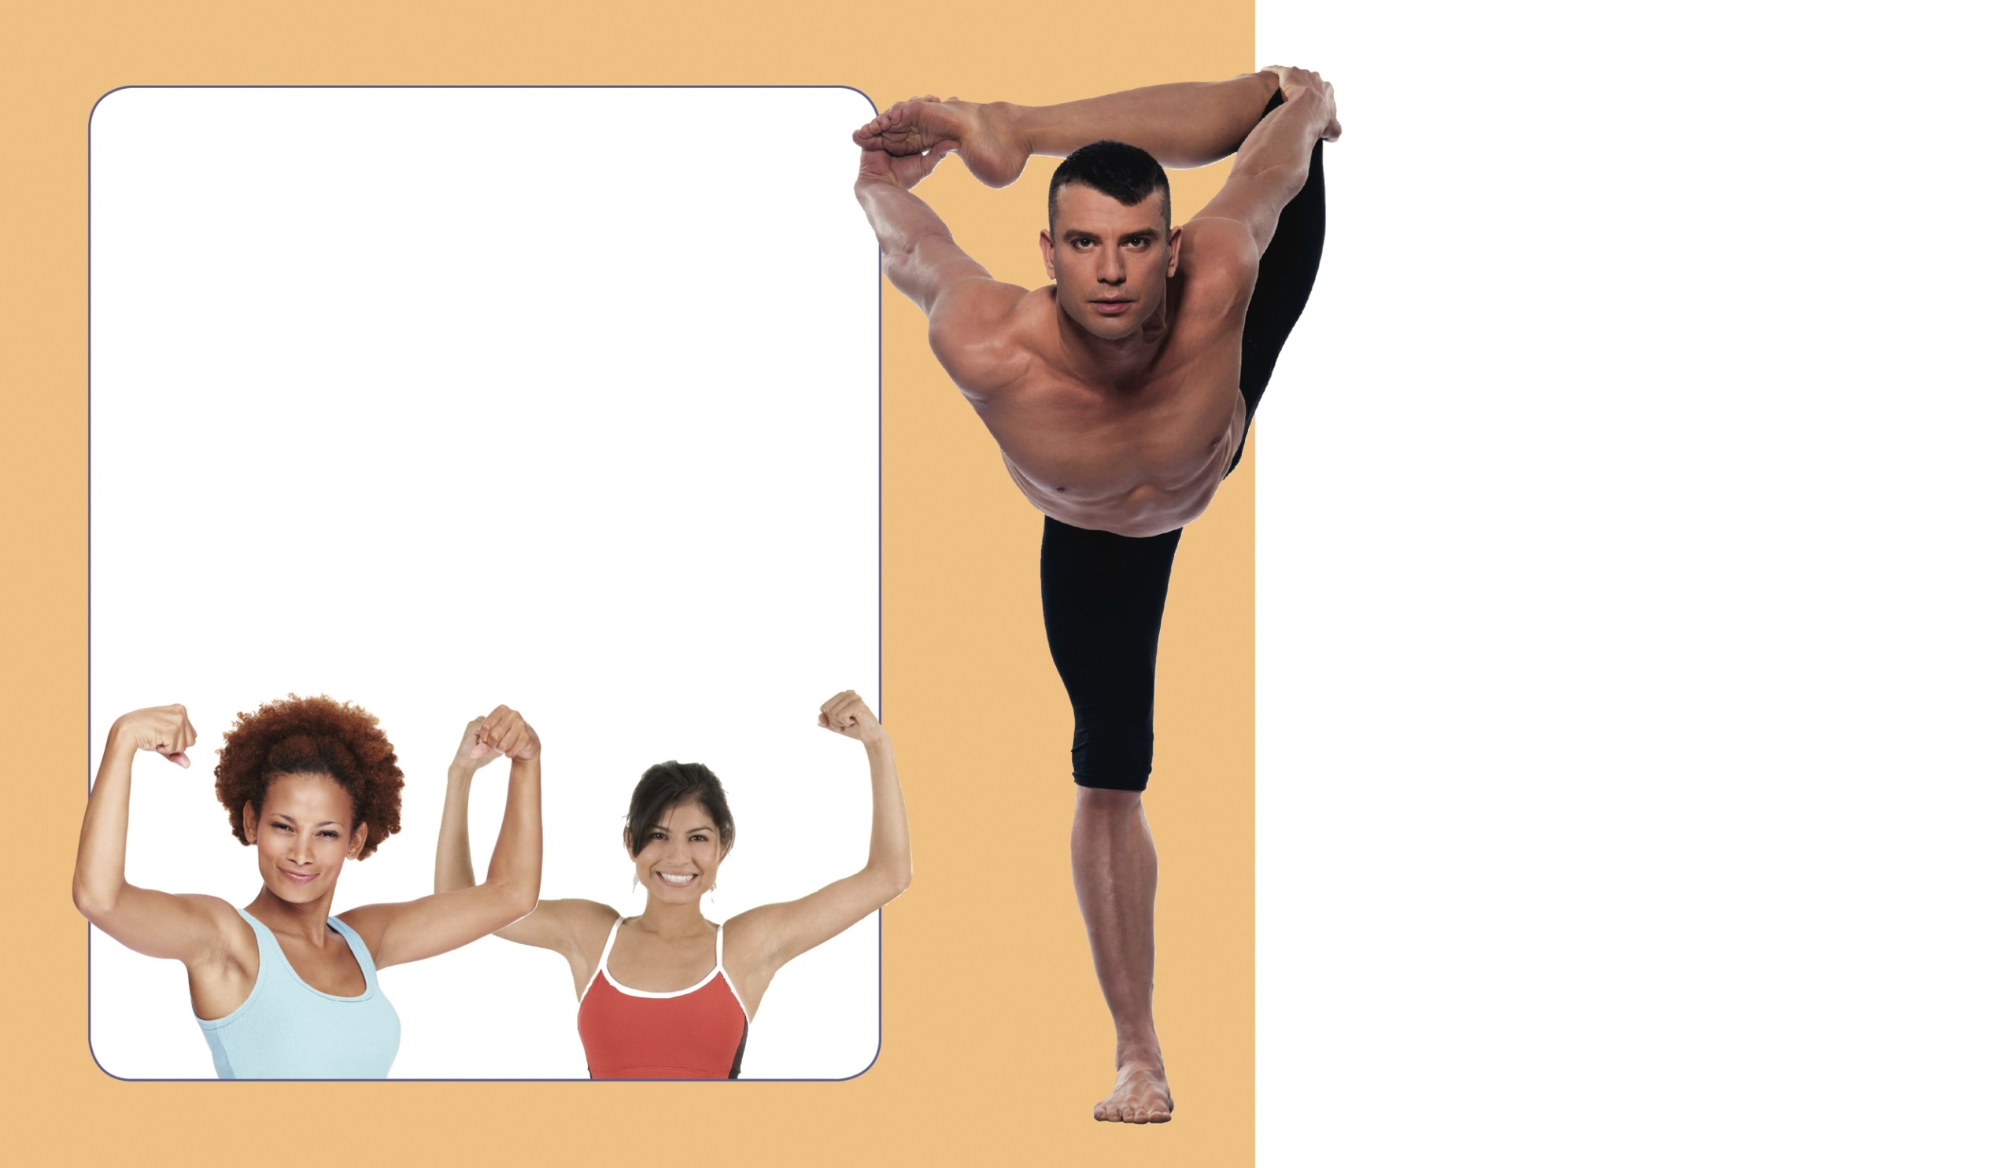
Scan to see a preview.
$30 a month
No enrollment fee
and the first month is on us!

Your membership includes
• Nautilus equipment (2 full circuits)
• Hip & Thigh reducing machine
• Hammer Strength
• Beginner’s circuit room
• 3,000 sq ft aerobic studio
• Kids programs
• Life fitness
• Cardio theater
• Body composition analysis
• and so much more!

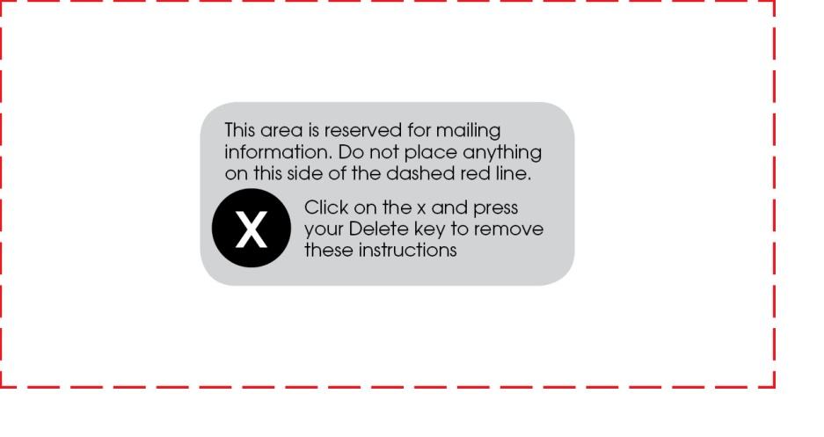
Visit www.perfectfitnesssite.com
for information on enrollment packages, personal trainers, etc.
Perfect Fitness
2967 Streetname St.
Yourtown, US 12345
www.perfectfitnesssite.com

