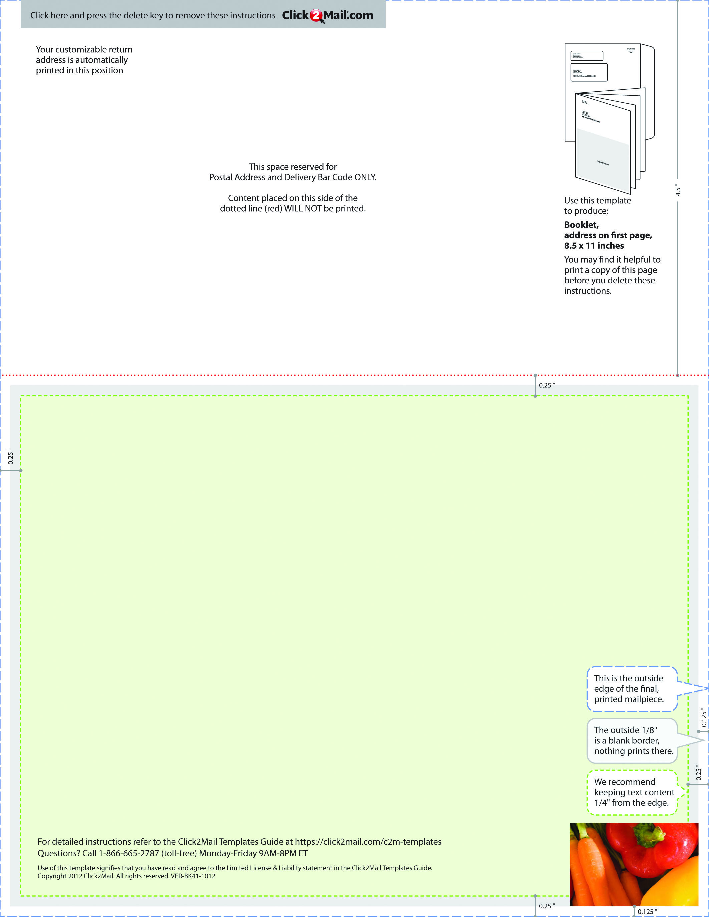
Placeholder text... Replace this placeholder text with text of your own. Use Click2Mail.com to print, finish, post, and deliver your mailpieces quickly and economically. Click2Mail.com makes it easy to design brilliant, full-color, affordable postal mail without permits, sorting, stamps, or trips to the Post Office. How does it work? We use a network of strategically located, high-quality printers to print, prep, and sort large volumes of mail daily. That network and our understanding of strict postal requirements allows your mailpiece to receive optimal handling and delivery. You benefit from high volume processing without setup fees or minimum quantities.
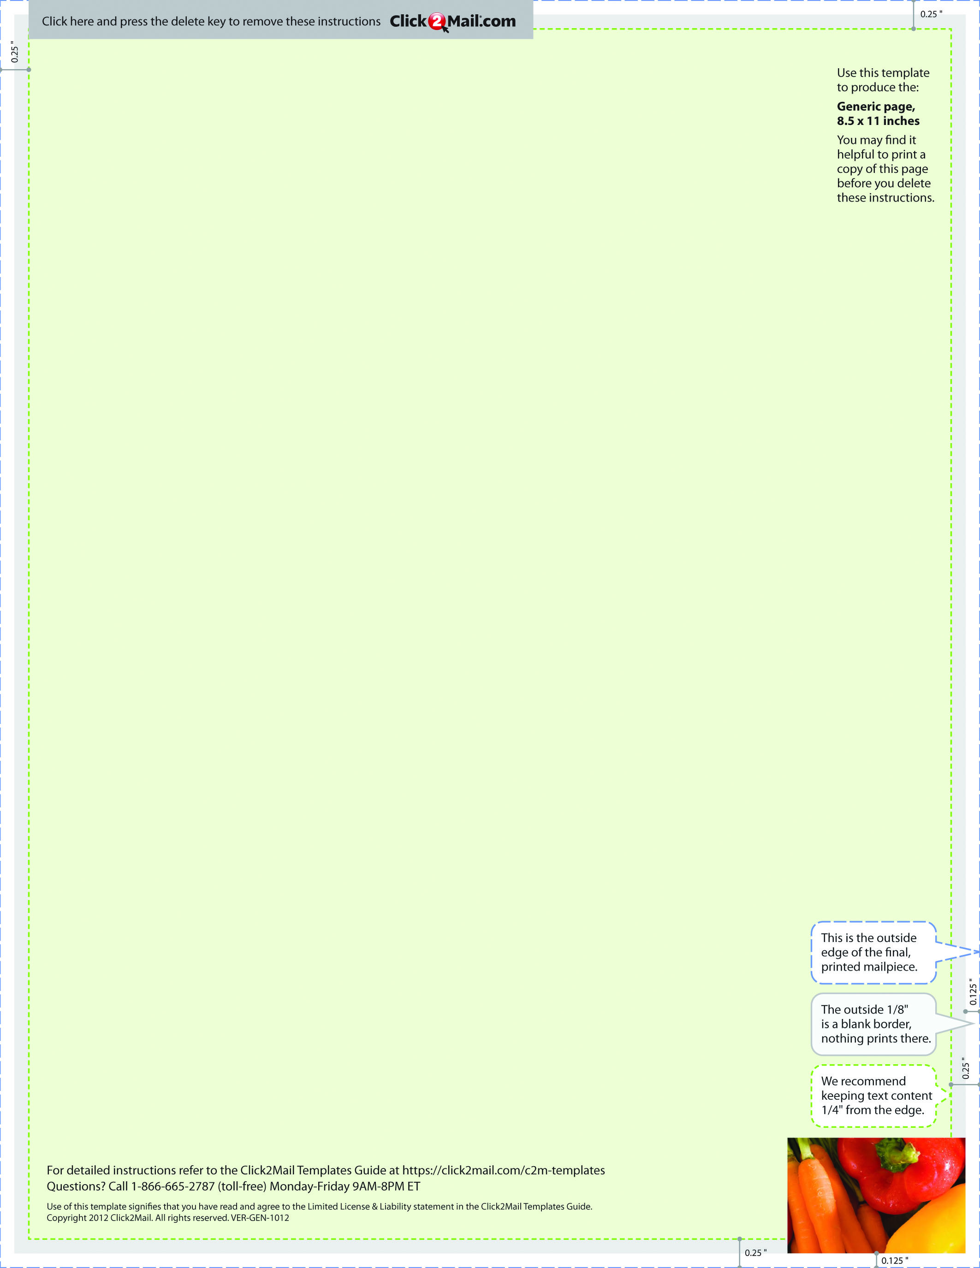

Placeholder text... Replace this placeholder text with text of your own. Use Click2Mail.com to
print, finish, post, and deliver your mailpieces quickly and economically. Click2Mail.com
makes it easy to design brilliant, full-color, affordable postal mail without permits, sorting,
stamps, or trips to the Post Office. How does it work? We use a network of strategically
located, high-quality printers to print, prep, and sort large volumes of mail daily. That network
and our understanding of strict postal requirements allows your mailpiece to receive optimal handling and delivery. You benefit from high volume processing without setup fees or minimum quantities.

Placeholder text... Replace this placeholder text with text of your own. Use Click2Mail.com to
print, finish, post, and deliver your mailpieces quickly and economically. Click2Mail.com
makes it easy to design brilliant, full-color, affordable postal mail without permits, sorting,
stamps, or trips to the Post Office. How does it work? We use a network of strategically
located, high-quality printers to print, prep, and sort large volumes of mail daily. That network
and our understanding of strict postal requirements allows your mailpiece to receive optimal handling and delivery. You benefit from high volume processing without setup fees or minimum quantities.

Placeholder text... Replace this placeholder text with text of your own. Use Click2Mail.com to
print, finish, post, and deliver your mailpieces quickly and economically. Click2Mail.com
makes it easy to design brilliant, full-color, affordable postal mail without permits, sorting,
stamps, or trips to the Post Office. How does it work? We use a network of strategically
located, high-quality printers to print, prep, and sort large volumes of mail daily. That network
and our understanding of strict postal requirements allows your mailpiece to receive optimal handling and delivery. You benefit from high volume processing without setup fees or minimum quantities.

