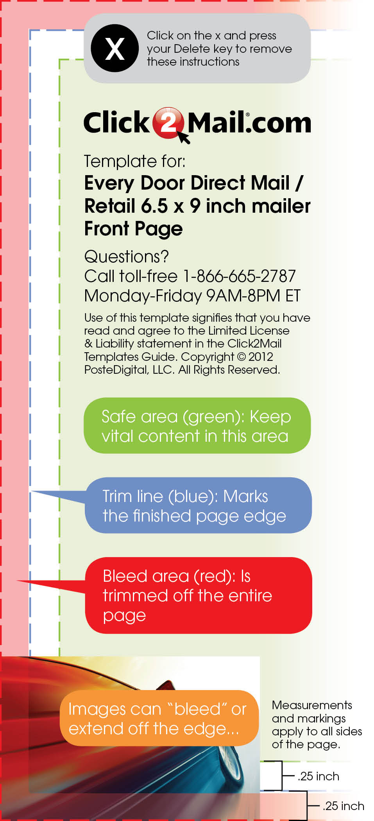
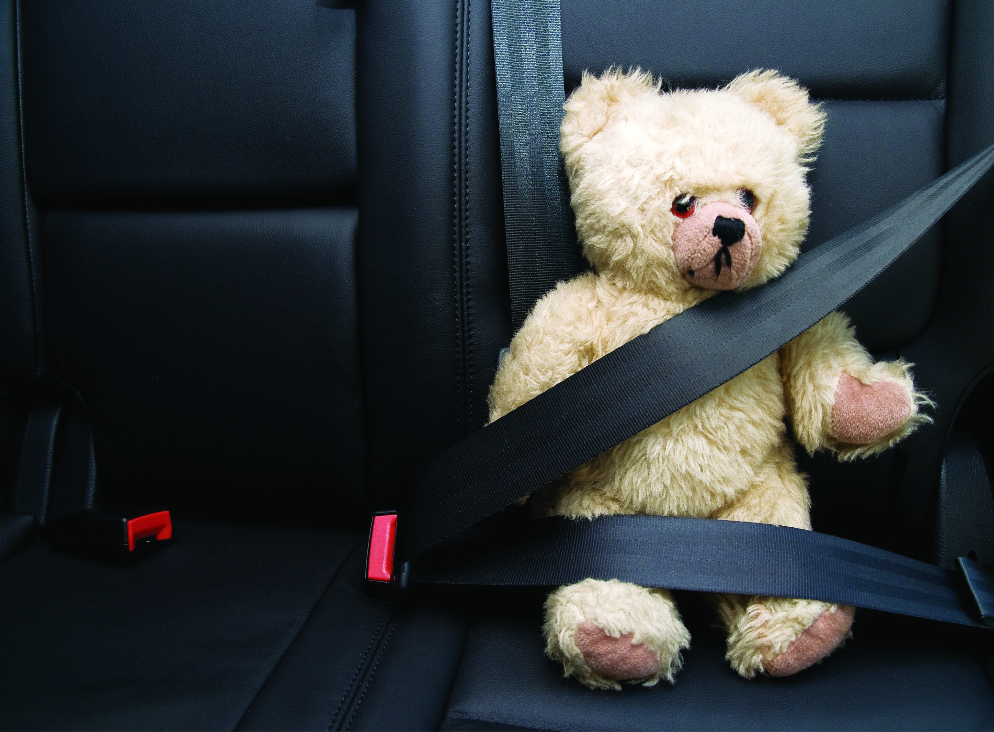
secure your future,
protect your assets

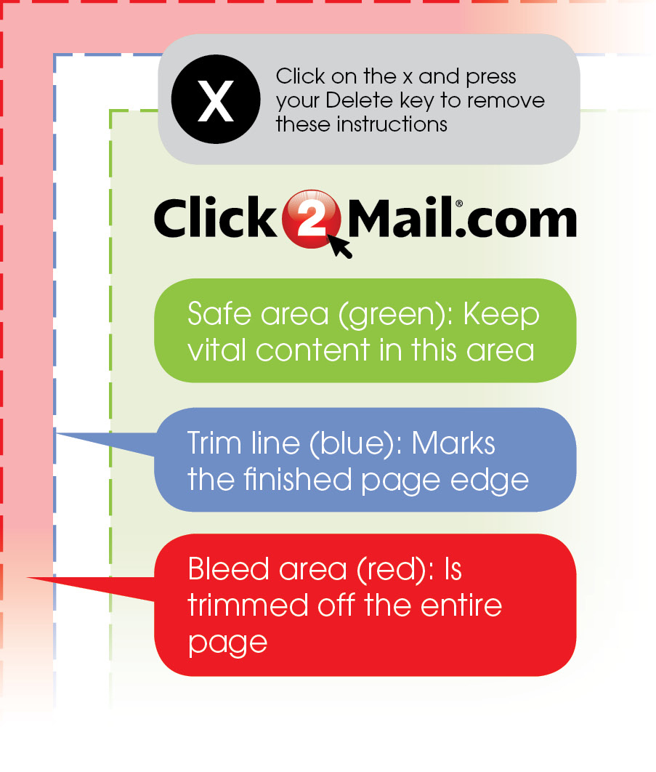

your interests

Protect

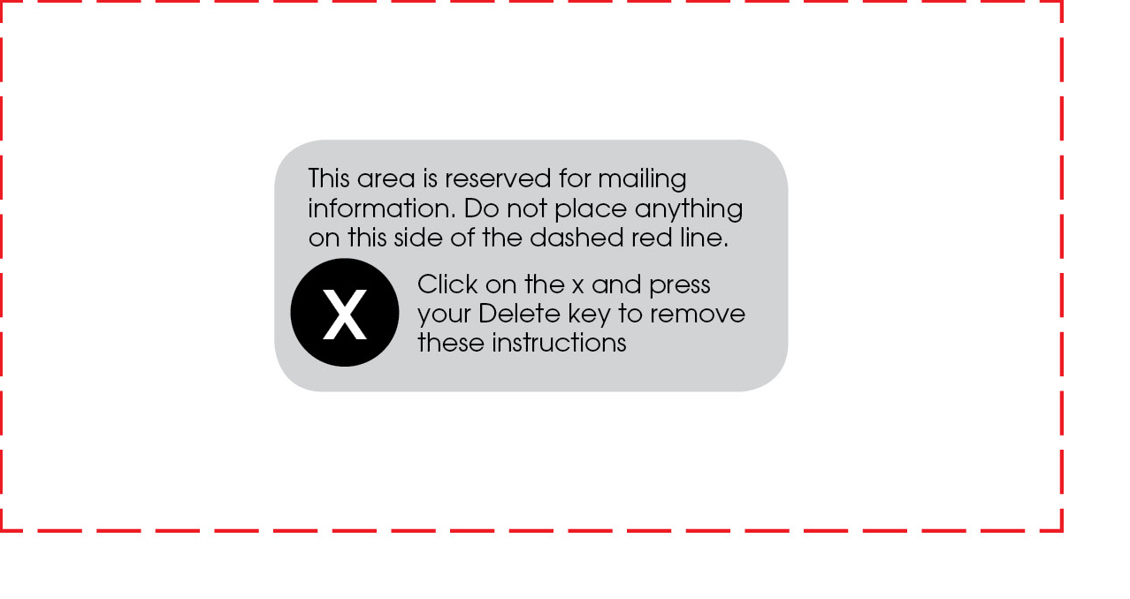

Call 555.462.3747 and mention this ad, and receive a free evaluation of your insurance needs.
No obligation
Free consultation
Life is easier when you know you have
a helping hand. Insurance Agency’s
Elizabeth Barone will help you
customize a package to meet your needs.
Elizabeth Barone
1926 StreetName St.
Yourtown, US 12345
P: 555.462.3747
E:ebarone@iagency.com
•Home
•Auto
•Health
•Life
•Disability

