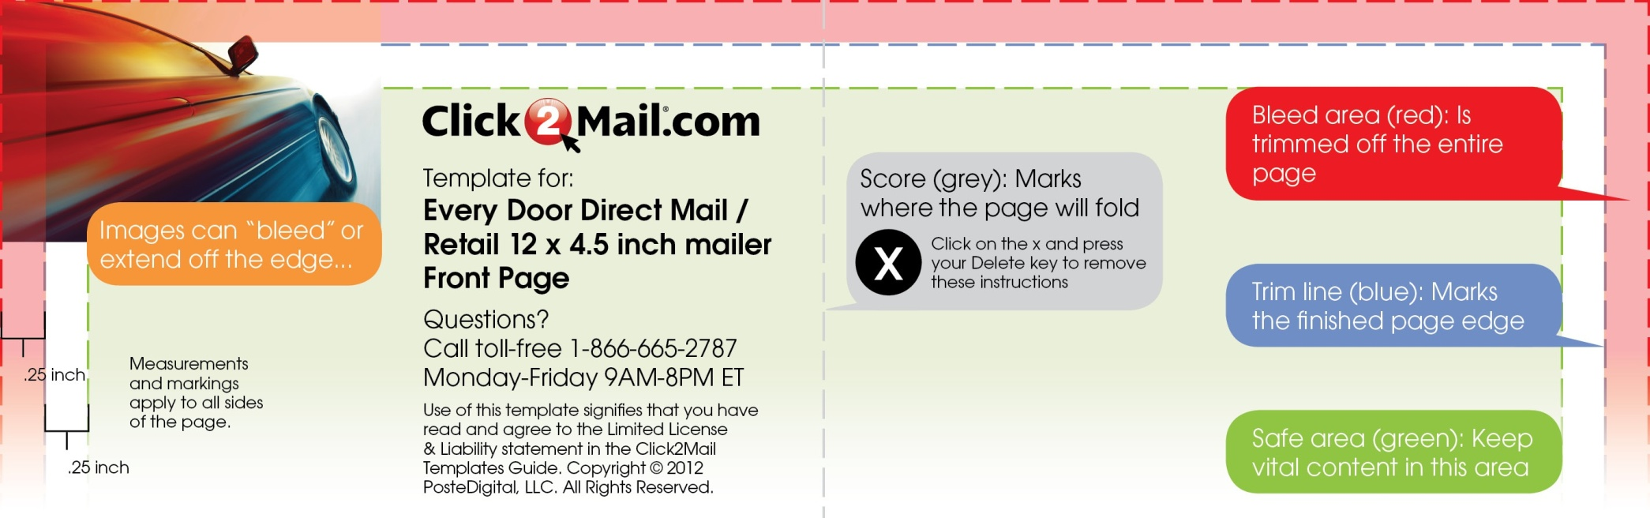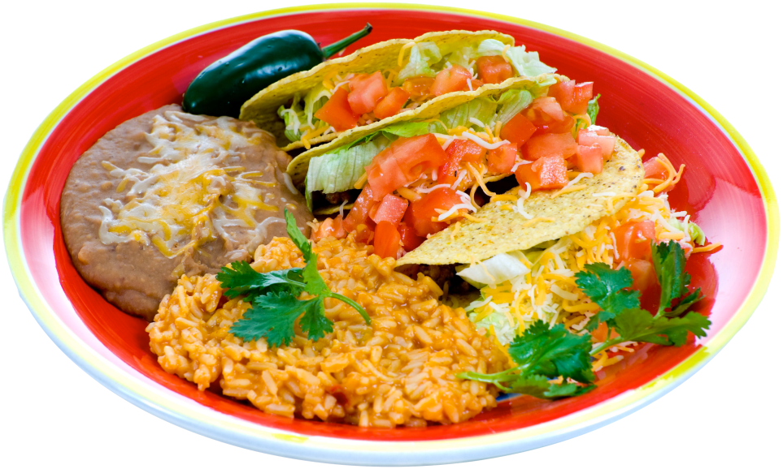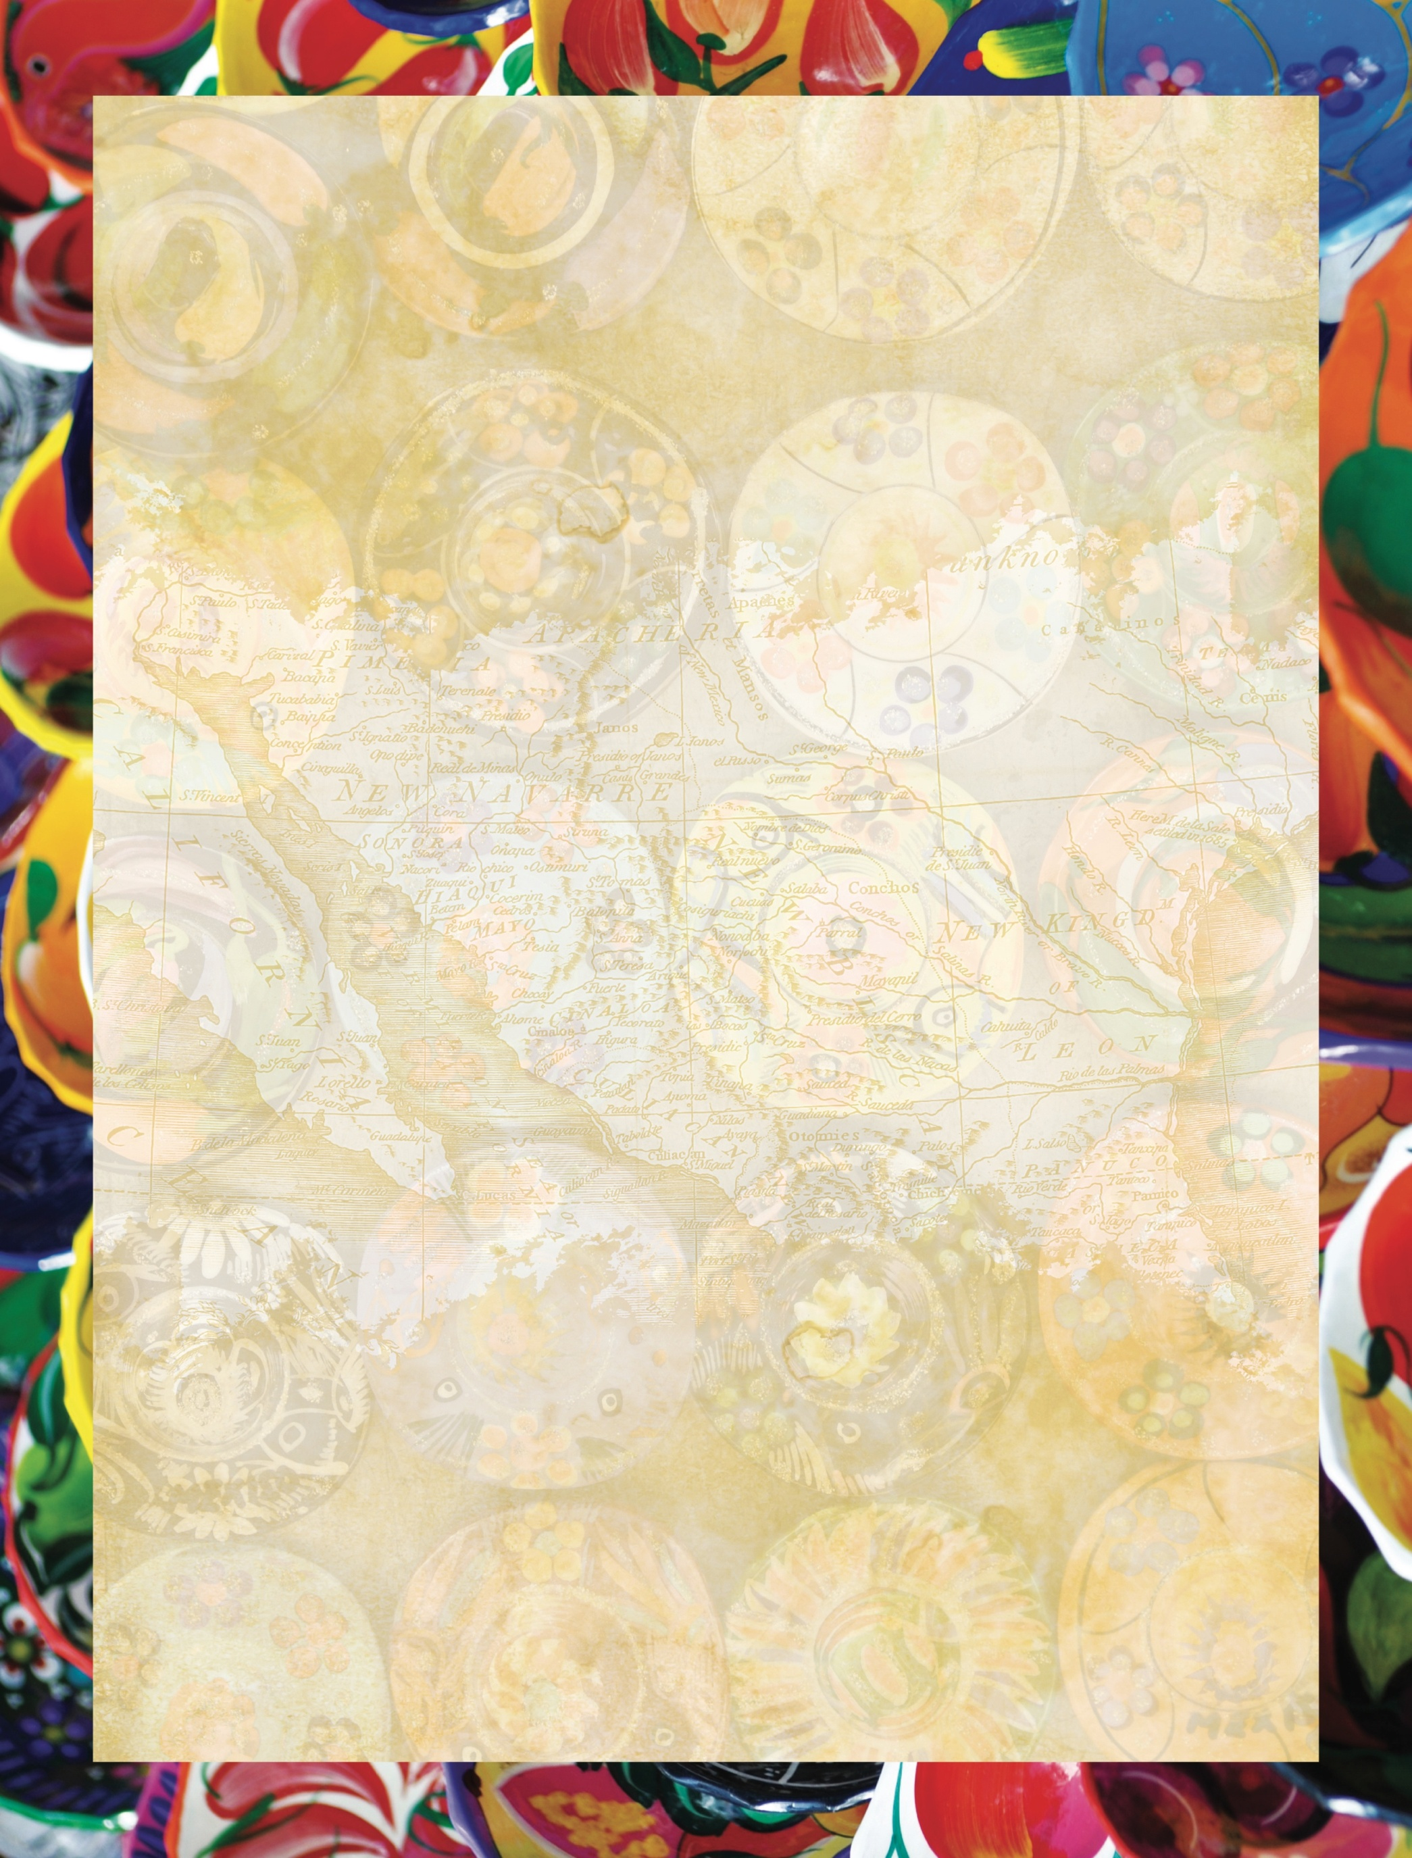

**entrees**

**Chimi** $6.95

One flour tortilla stuffed with cheese and your choice of chicken, ground or shredded beef deep fried to a golden brown and topped with sour cream, guacamole, cheese and fresh tomato . Served with rice and refried beans

**Fajitas** $8.50

Your choice of steak, chicken or shrimp grilled with onion, mushroom, green pepper, red peppers and Mexican spices. Topped with melted cheese. Served with two tortillas, refried beans, sour cream and pico de gallo

**Tacos** $6.25

Two corn tortillas stuffed with your choice of chicken, shredded beef or ground beef; deep fried and topped with lettuce, fresh tomato and cheese. Served with rice and refried beans

Served with soft flour tortillas $6.50

**Tamales** $6.95

Two tamales served with a side of rice and beans and a cup of chili beans

**Tostadas** $6.25

One flat tortilla shell with your choice of ground beef, chicken or shredded beef; topped with lettuce, tomato, sour cream, guacamole and cheese. Served with rice and refried beans

**Taco Salad** $6.95

A giant crispy flour tortilla bowl filled with a fresh tossed salad, your choice of seasoned chicken, ground beef or shredded beef topped with cheese, tomatoes, green pepper, green olives and black olives

**Burritos** $6.50

A flour tortilla filled with your choice of ground beef, chicken or shredded beef topped with sour cream, cheese and freshtomatoes. Served with spanish rice and refried beans

Chicken or steak fajita burrito $6.95

**Enchiladas** $6.25

A corn tortilla dipped in enchilada sauce stuffed with cheese and topped with your choice of chicken or ground beef and cheese. Served with spanish rice and refried beans

**combinationS**

**Veggie Combo** $6.95

One bean burrito and one cheese quesadilla served with a side of spanish rice and refried beans

**Maya Combo** $6.95

One ground beef taco and one chicken enchilada served with a side of spanish rice and refried beans

**Aztec Combo** $6.95

One ground beef and one chicken burrito topped with cheese, fresh tomatoes, spanish rice and refried beans

**A LA CARTE**

**APPETIZERS**

**Nachos** $5.75

Layer of chips topped with cheese, tomatoes, green pepper, onion, jalapenos and sour cream

With chicken or ground beef $6.75

**Botana** $6.75

Layers of chips with beans, mexican sausage & cheese topped with lettuce, green pepper, tomato, black olives avacado and sour cream

**Queso Fundido** $6.25

Mixture of melted cheese and mexican sausage served with three hot flour tortillas

**Quesadilla** $5.25

A Flour tortilla stuffed with shredded cheese and pan fried to a golden brown and topped with fresh tomatoes and sour cream

With chicken or steak fajita $6.25

With rice and refried beans $7.50

**Jalapeño Poppers** $5.50

Six Jalapeños stuffed with cream cheese and deep fried to a golden brown . Served with ranch dressing

**Guacamole**

Fresh avocados ground and mixed with mexican spices and served on a bed of lettuce with chips

(small) $5.50

(large) $7.25

**Chicken Wings** $6.50

Hot, spicy flavored wings with blue cheese dressing

**Tortilla Soup**

Delicious blend of roasted tomatoes, chicken stock and spices, topped with crispy corn tortillas, avacado and cheese Cup $3.00

Bowl $4.25

**Chili**

Cup $3.00

Bowl $4.25

Soft Taco $1.95

Enchilada $2.25

Flauta $1.75

Hard Taco $1.75

Burrito $4.25

Chimi $5.25

Soft Taco $1.95

Enchilada $2.25

Flauta $1.75

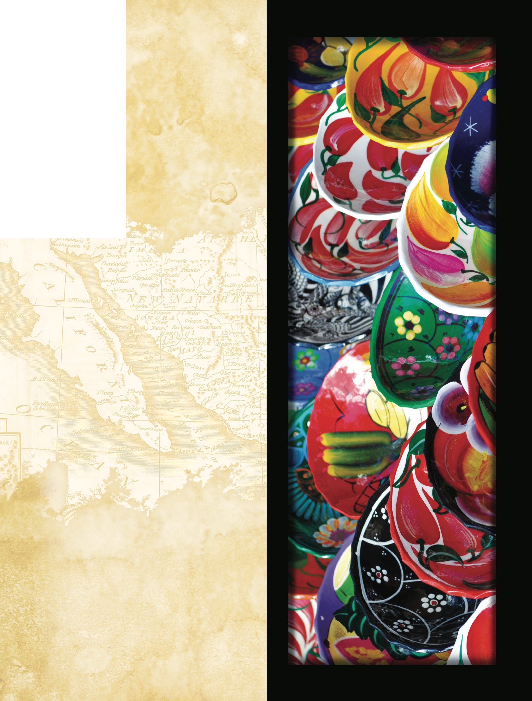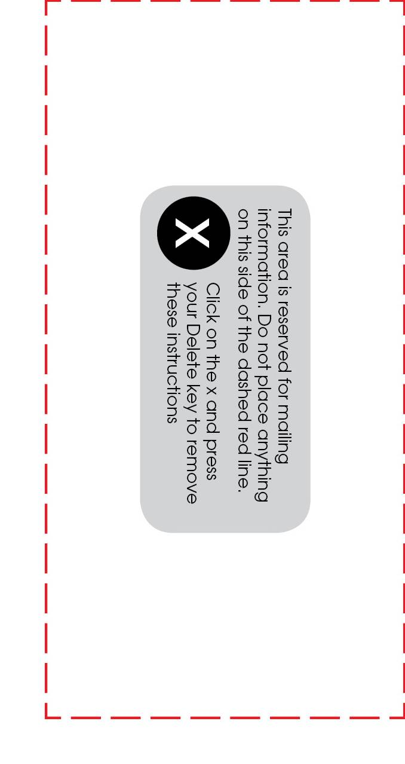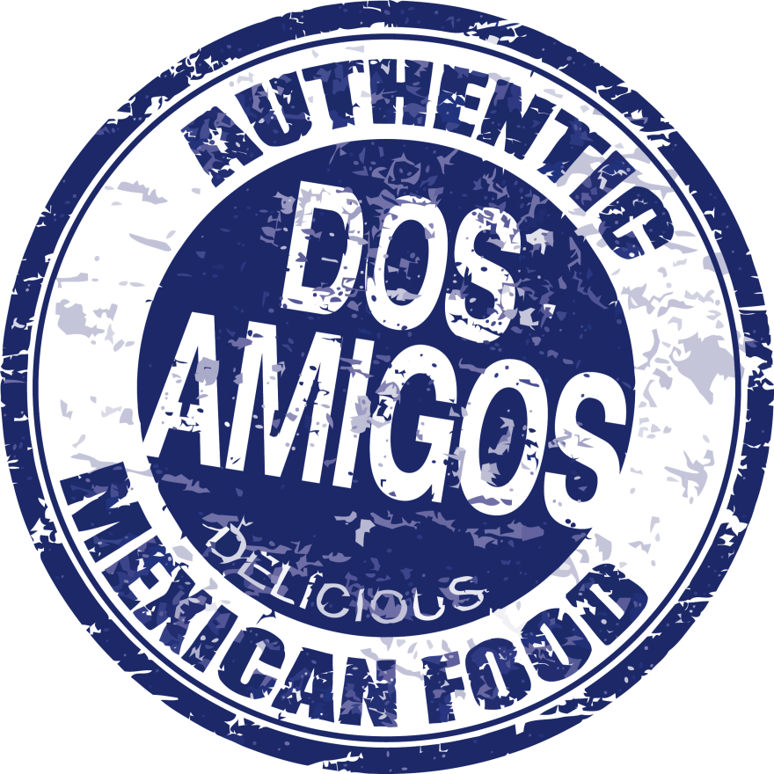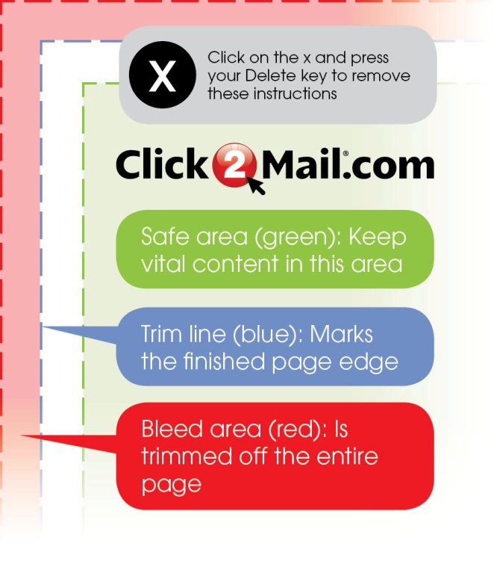

**side orderS**

Spanish Rice $1.75

Side of Cheese $2.75

Sour Cream $0.75

Cup of Chili $3.00

French Fries $2.50

Jalapeños $0.75

Olives $0.75

Refried Beans $1.75

Basket of Chips $1.50

Guacamole $2.75

Bowl of Chili $4.25

Cheese Dip $2.75

Shredded Lettuce $0.75

Soft/Hard Taco $1.75

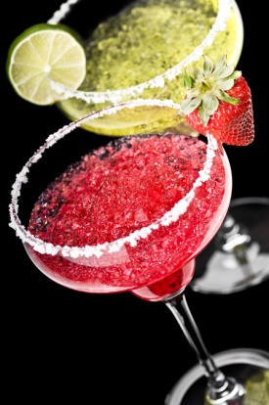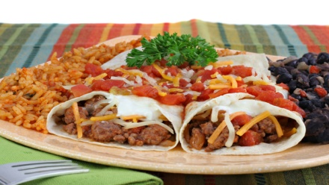

LUNCH MENU

**DOS AMIGOs**

127 Streetname St.

Yourtown, US 12345

**555-123-4567**

Mon.-Thurs. 11am-10pm

Fri.-Sat. 11am-11pm

Sun. 11am-9pm

**dessert**

**Fried Ice Cream** $4.50

With your choice of chocolate or strawberry topping and whipped cream

**Chocolate Cake** $4.50

**Flan** $4.50

**Sopapillas** $4.50

Crispy flour tortillas and cobbler toped with sugar, cinnamon and honey

**Cheese Cake Burrito** $4.50

Golden, deep-fried burrito filled with creamy lemon cheesecake

**Drinks**

Coke • Diet Coke • Mellow Yellow

Mr.Pibb • Sprite • Coffee • Tea $2.00

Margaritas $4.50

Grande Margarita $5.75

Beer (Domestic) $3.00

Imported $3.25

Well Drinks $5.00

(Top Shelf $2 .00 more)

Wine by the glass $5.50

(Chardonnay • White Zinfandel • Cabernet)